1. **Make a simple dashboard and show columns, bar charts, line charts, and area charts.**

**Ans-**

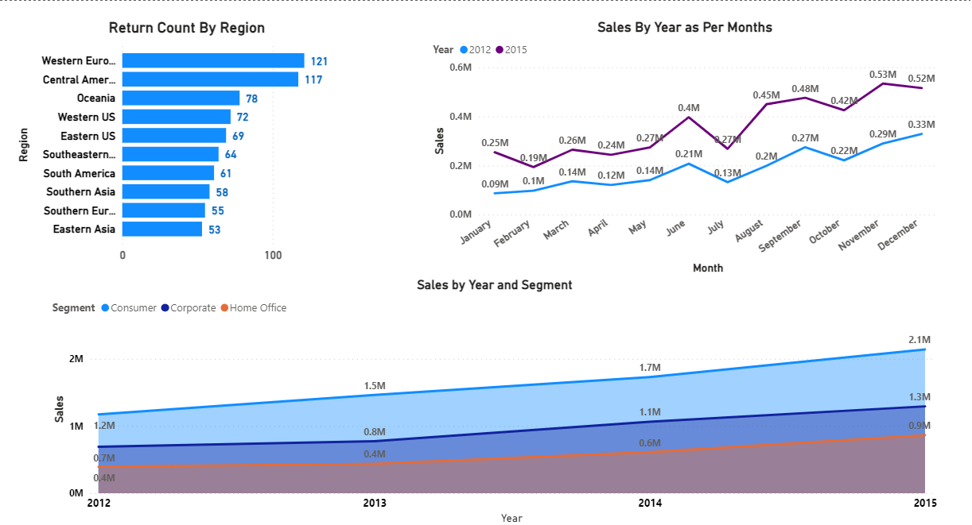

1. **Make a simple dashboard and show combination chart, Scatter chart, Shape chart, and Treemap chart.**

**Ans-**

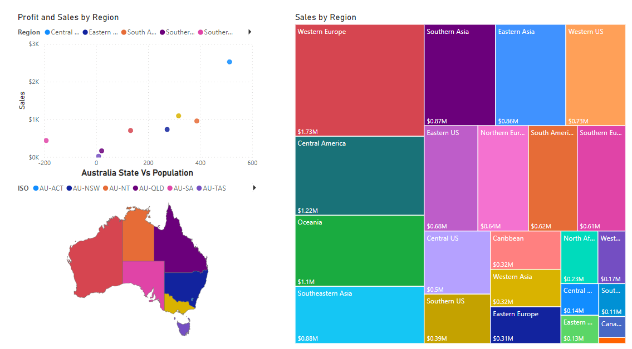

1. **Make a dashboard and show 2 maps visualization i.e. basic map and filler maps.**

**Ans-**

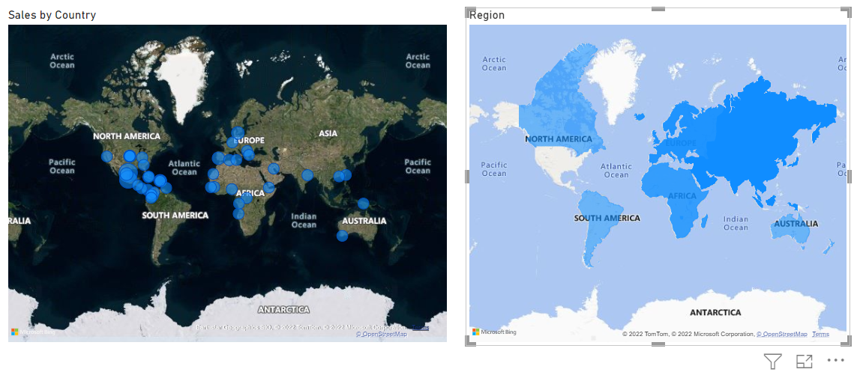

1. **Create a report which has:**

**Bar chart, Card visualizations, Combo chart visualizations, Matrix visualizations, Column chart visualizations**

**Guide: Sales data can be used**

1. **Make a report to analyze product sales using treemap visualization.**
2. **Make a dashboard on sales data (Minimum 4 tiles).**

**Ans-Q 4,5 and 6**

